ZEPTO ANALYSIS
- See all the data imported:
SELECT * FROM bronze.zepto_grocery_data;
- DATA CLEANING: Cleaning the Item Fat_Content field ensures data consistency and accuracy in analysis. The presence of multiple variations of the same category (e.g., LF, low fat vs. Low Fat) can cause issues in reporting, aggregations, and filtering. By standardizing these values, we improve data quality, making it easier to generate insights and maintain uniformity in our datasets.
CASE
WHEN item_fat_content IN('LF','low fat') THEN 'Low Fat'
WHEN item_fat_content IN('reg') THEN 'Regular'
ELSE item_fat_content
END AS item_fat_content;
After using this query in new select statement insert in into silver.zepto_grocery_data
SELECT * FROM silver.zepto_grocery_data;

For making sure it worked right run the below query:
SELECT DISTINCT item_fat_content FROM silver.zepto_grocery_data;

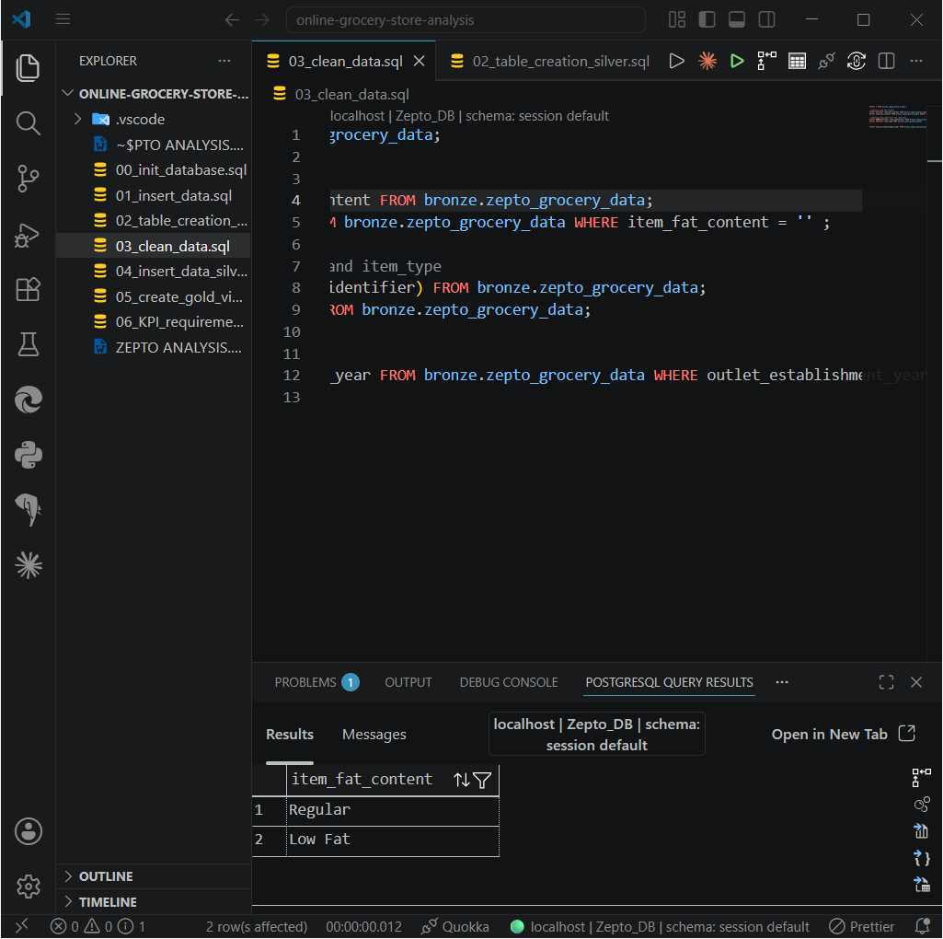

- KPI’S

- Total Sales:
SELECT
Concat(((SUM(total_sales)/1000000)::Decimal(10,2)),' million') AS total_sales_millions
FROM gold.grocery_analysis;

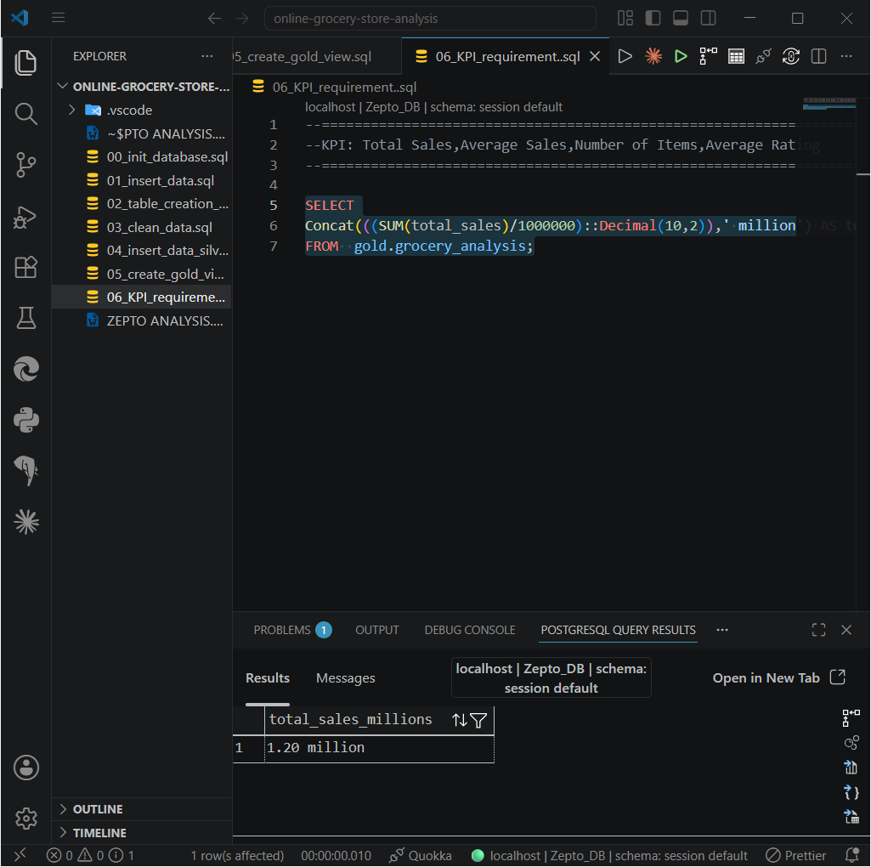

- Average Sales
SELECT
((AVG(total_sales))::INT) AS Avg_sales
FROM gold.grocery_analysis;

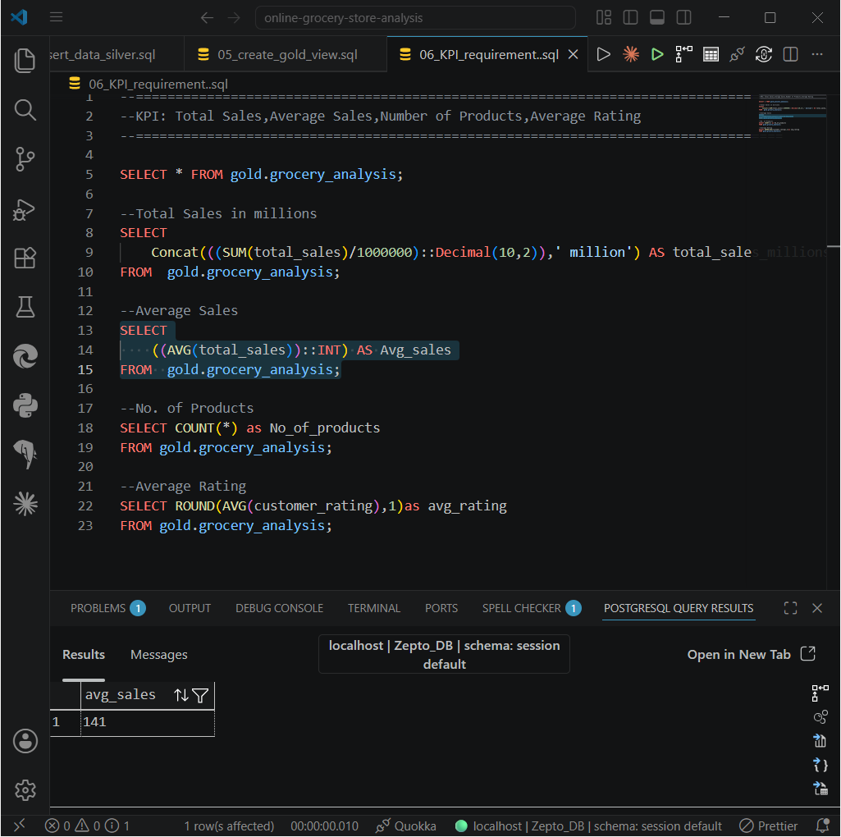
- Number of Products
SELECT COUNT(*) as No_of_products
FROM gold.grocery_analysis;

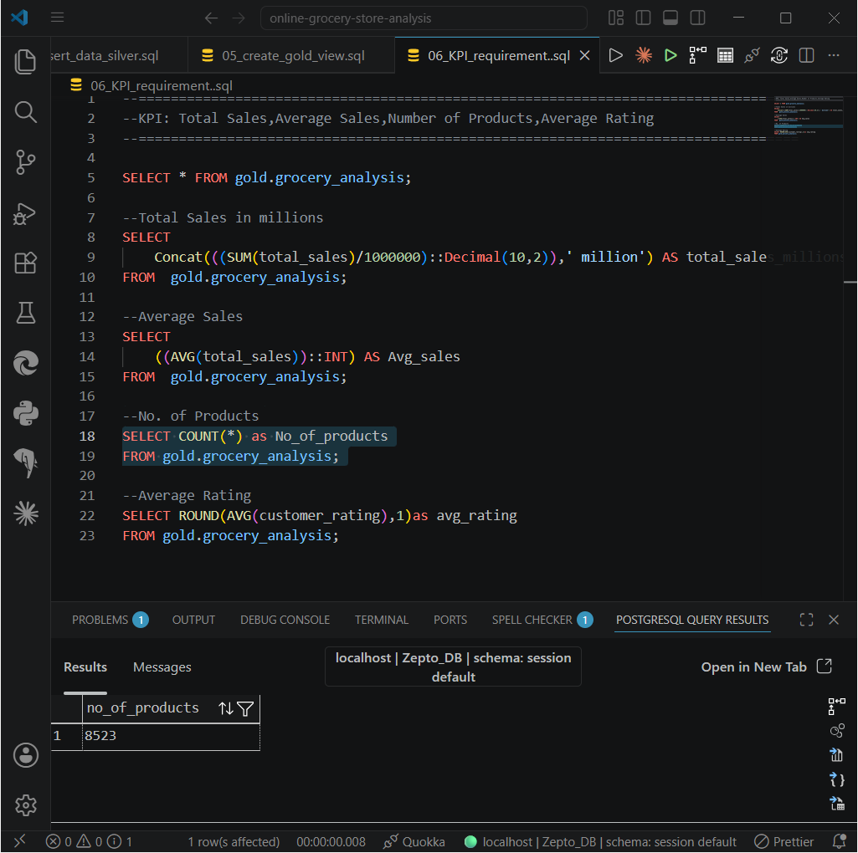

- Average Rating
SELECT ROUND(AVG(customer_rating),1)as avg_rating
FROM gold.grocery_analysis;
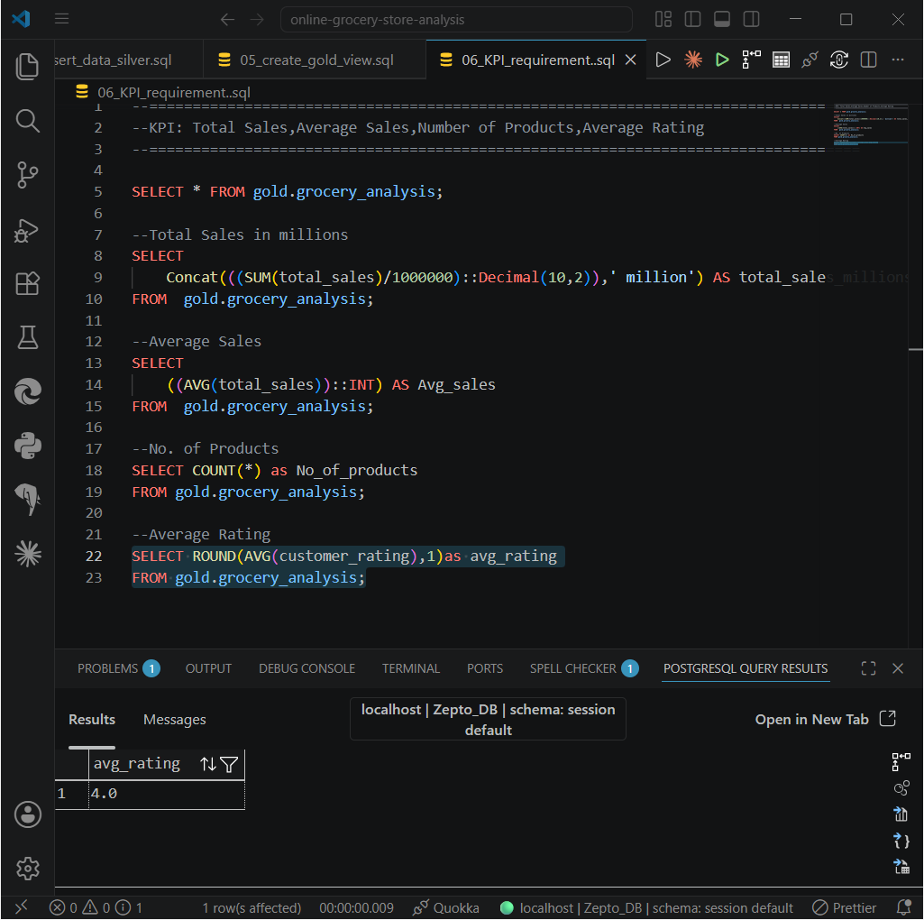
- Granular Requirements
- Total Sales by Fat Content
SELECT
fat_content,
ROUND(SUM(total_sales),2) AS total_sales,
ROUND((AVG(total_sales)),1) AS Avg_sales,
COUNT(*) AS No_of_products,
ROUND(AVG(customer_rating),1) AS avg_rating
FROM gold.grocery_analysis
GROUP BY fat_content
ORDER BY total_sales DESC;

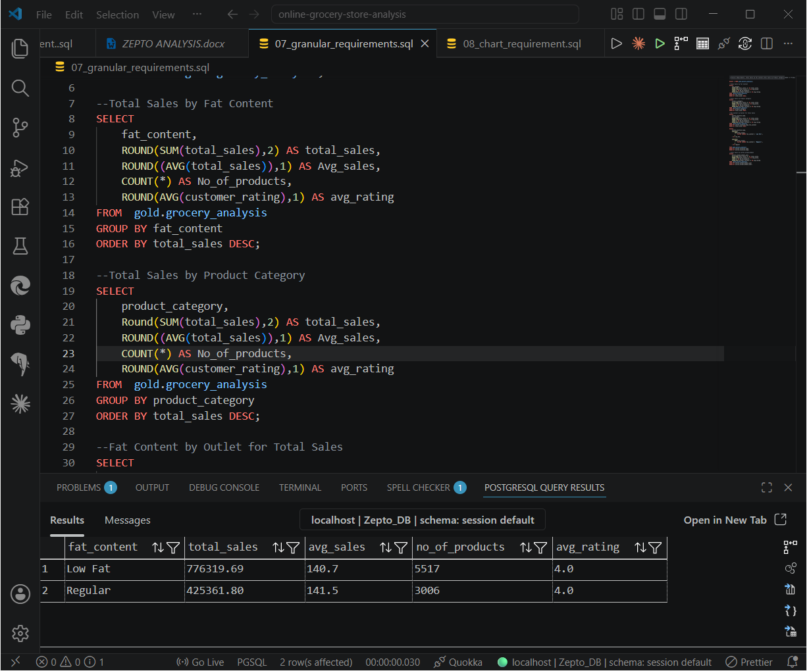
- Total Sales by Product Category
SELECT
product_category,
Round(SUM(total_sales),2) AS total_sales,
ROUND((AVG(total_sales)),1) AS Avg_sales,
COUNT(*) AS No_of_products,
ROUND(AVG(customer_rating),1) AS avg_rating
FROM gold.grocery_analysis
GROUP BY product_category
ORDER BY total_sales DESC;
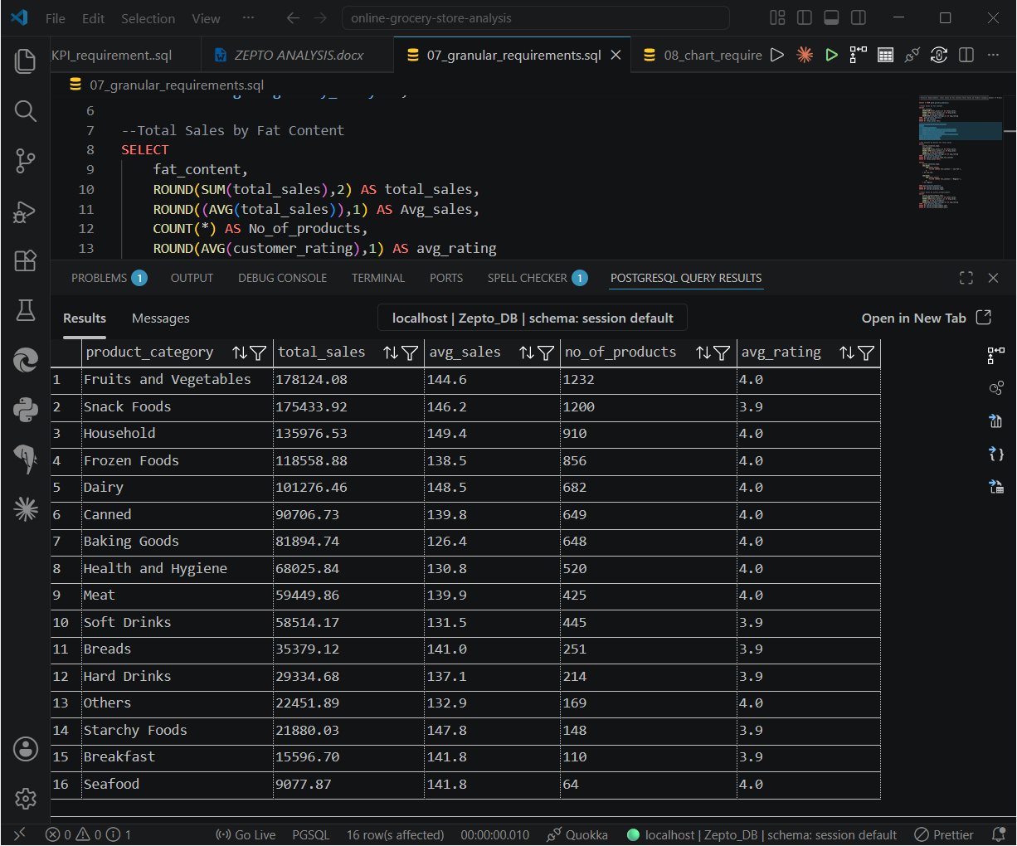
- Fat Content by Outlet for Total Sales
SELECT
outlet_location_type,
COALESCE( SUM(total_sales)
FILTER (WHERE fat_content = 'Low Fat'), 0
) AS low_fat,
COALESCE( SUM(total_sales)
FILTER (WHERE fat_content = 'Regular'), 0
) AS regular
FROM gold.grocery_analysis
GROUP BY outlet_location_type
ORDER BY outlet_location_type;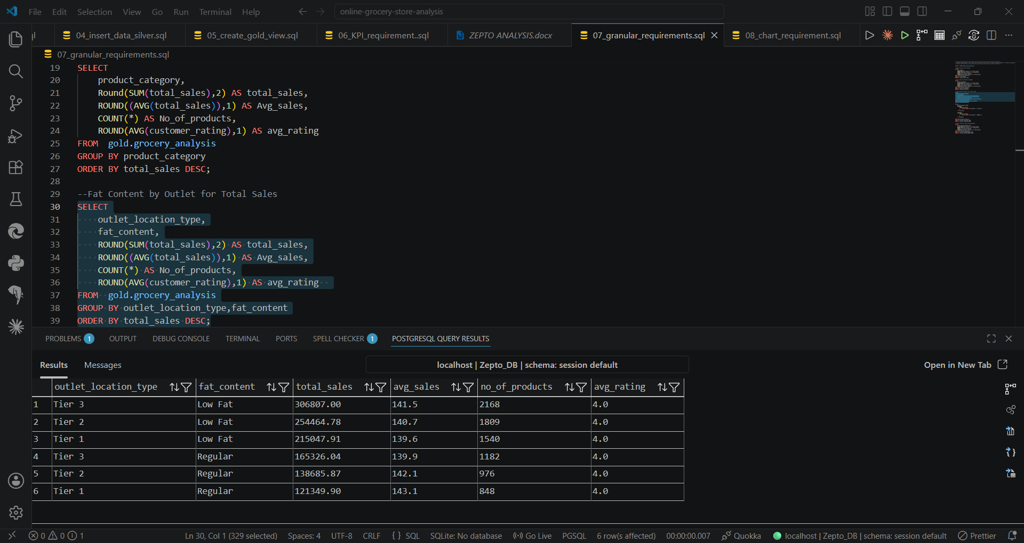
- Total Sales by outlet_establishment
SELECT
outlet_establishment_year,
Round(SUM(total_sales),2) AS total_sales,
ROUND((AVG(total_sales)),1) AS Avg_sales,
COUNT(*) AS No_of_products,
ROUND(AVG(customer_rating),1) AS avg_rating
FROM gold.grocery_analysis
GROUP BY outlet_establishment_year
ORDER BY outlet_establishment_year;
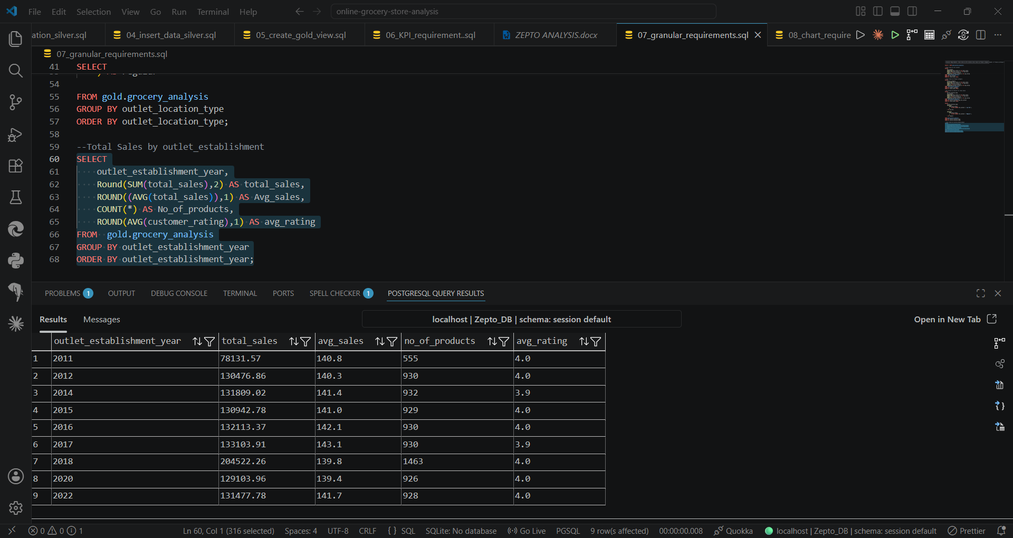

- Chart Requirements
- Percentage of Sales by Outlet Size
WITH sales_by_size AS (
SELECT
outlet_size,
SUM(total_sales) AS total_sales
FROM gold.grocery_analysis
GROUP BY outlet_size
)
SELECT
outlet_size,
total_sales,
ROUND(
total_sales * 100.0 /
SUM(total_sales) OVER (),
2
) AS sales_percentage
FROM sales_by_size
ORDER BY total_sales DESC;

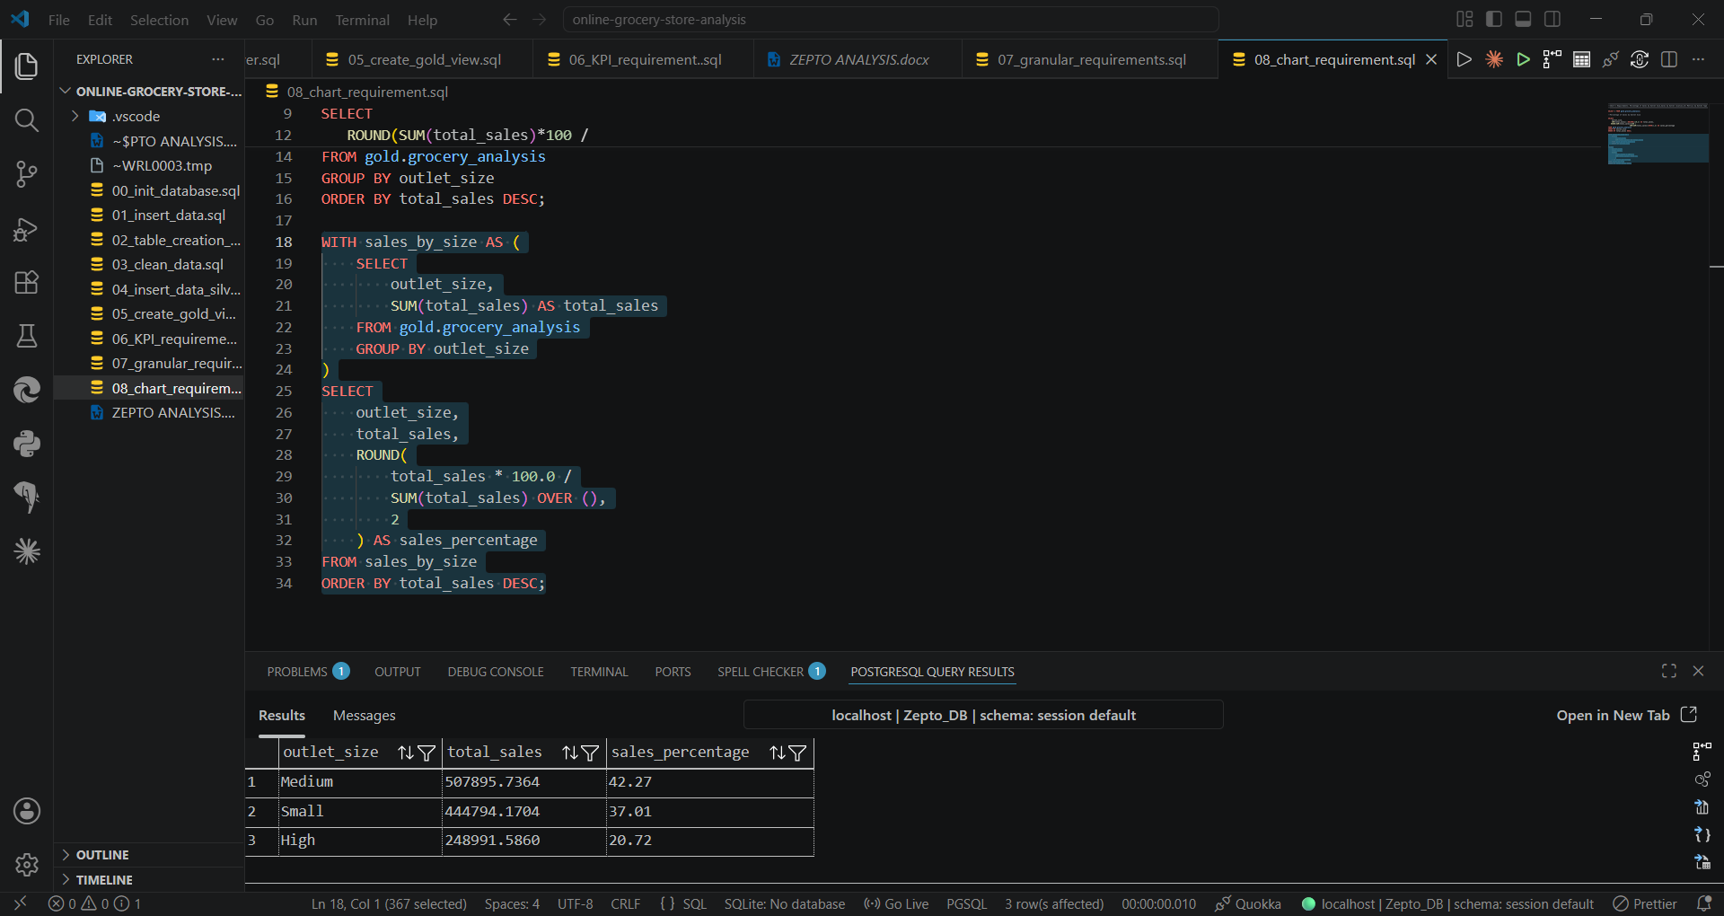

- Sales by Outlet location
SELECT
outlet_location_type,
Round(SUM(total_sales),2) AS total_sales,
ROUND((AVG(total_sales)),1) AS Avg_sales,
COUNT(*) AS No_of_products,
ROUND(AVG(customer_rating),1) AS avg_rating,
ROUND(SUM(total_sales)*100 /
SUM(SUM(total_sales))OVER(),2) AS sales_percentage
FROM gold.grocery_analysis
GROUP BY outlet_location_type
ORDER BY outlet_location_type;

